Ereader with Remote Wireless Thermistor
By Kevin Kuczek
11/8/21 *Update 12/4/21
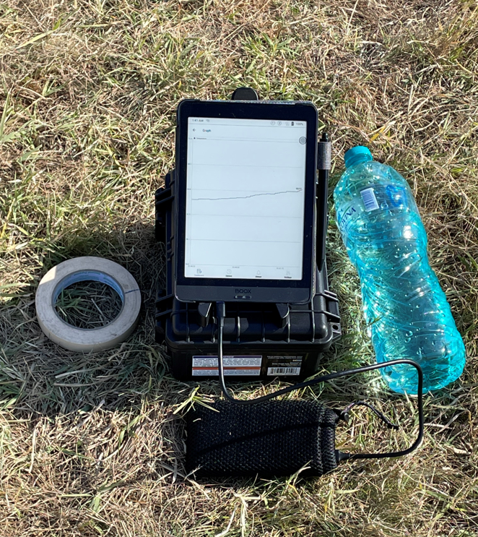

Parts List
- Onyx Boox Nova 3 (or other compatible ereader that is Android/IOS compatible)
https://onyxboox.com/ $250 or cheaper on ebay for used. *Update 12/4/21. Boox Nova Pro will not work. Here, my guess is that the processor is too slow. The Boox Nova 2 and Nova 3 will work. And very likely the newest, the Boox Nova Air will work, though I have not tried yet.
- Icelsius Wireless Pro Temperature Sensor $90.00
https://www.icelsius.com/product/icelsius_wireless_pro_page
- Thermistor- 10K ohm NTC equivalent. $5.00 or so from Digikey.
- Foam/mylar thermistor sun shield- pictures attached and one made by George Gassaway. $1 or so.
- 7’ tall telescoping tri-pod photography lighting pole to mount thermistor on. $30.00 https://amzn.to/3CBqNtu
- Harbor Freight storage box. $13. https://www.harborfreight.com/1800-weatherproof-protective-case-small-64550.html
Total = $390.00 or less.
History
There were a number of people who inspired this project and I thought that the history behind might interest some. In 1998, I participated in my first World Space Modeling Championships flying the S6A streamer duration event. My teammates were Ross Hironaka and George Riebesehl. Also, and who I would consider a teammate was George Gassaway who had lugged a hardwired thermistor temperature sensor that outputted to a printer. This printer graphed the temperature over time on the old punch green/white scrolling paper using a stylus pen. Important is that we were able to see temperature trends as they were happening at our launch pads and since the thermals were cyclic at this meet, we were able to predict the next thermal coming in. Of course the models are important, but being able to pick air based on rising air temperatures was paramount in our S6A team gold medal success.
A lot of people since have been using a Kestrel weather station. The Kestrel is compact but the small 1.5”x1” screen that scans over a 3 minute period has some disadvantages. One is that actually seeing a rise in temp happens very slowly on the screen since it shows a 3 minute trace over a 1.5” screen. Typically, US teams were following and not leading when signaling to launch because of. By the time the Kestrel saw a large thermal, there were already lots of countries who were in the queue to launch. And the US was last and sometimes had to wave off a launch since the thermal had already passed.
Next up was Dr. Andrew Tomasich who had incorporated a PC with multiple sensors. Again, seeing the output proved to be a challenge and a separate sunshade over the PC was needed. The PC also required a hefty battery backup package. Only one person could view the data coming in. George Gassaway also rigged a Velleman handheld oscilloscope with a thermistor, but the display heated up and would shut down. So, again a sunshade was needed and only one person could view at a time.
With the new ereader/wireless thermistor setup devised in 2021, temperature trends could be seen very quickly. These trends were fully visible no matter the lighting conditions and the sampling rate was very fast at one sample every ½ second. An additional benefit is that all at the launch site were able to view it. Maximum distance from the wireless sensor to the ereader is around 200’ and it also seems to be affected by line of sight. So, my hunch is if the sensor is put up on a taller pole, the distance may be able to be increased.

Building
The Icelsius wireless sensor will need to have its metal temperature sensor probe removed and a new 10K ohm thermistor soldered on. Use heat shrink tubing around your solder connections and another piece of heat shrink tubing around all and up to the thermistor head for added rigidity. A picture of the new thermistor soldered onto the ICelsius wiring harness is below.
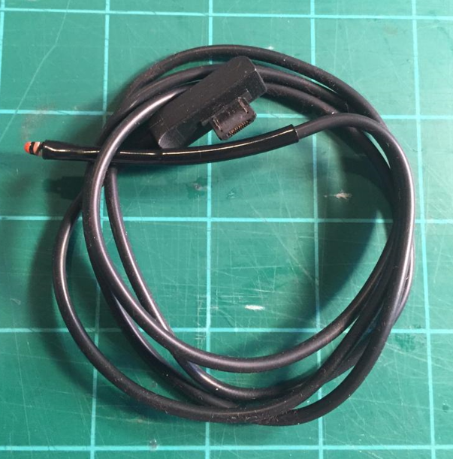

I also used a sun shield that George Gassaway gave me a while back. This was simply taped to the top of the lighting pole and the thermistor was inserted into the launch lug underneath. It is made with foam, mylar tape and toothpicks.
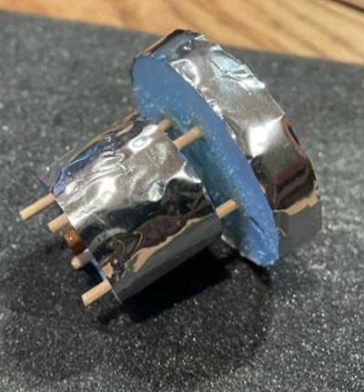
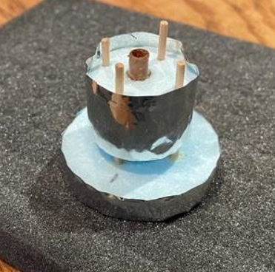

Software
Icelsius offers its own software package for free and it is available either for IOS or Android operating systems. When operating on the Onyx Boox ereader, the Android version is required and can be downloaded using the Google play application platform. Here is an article that details steps on how to enable Google play on the Onyx ereader: https://blog.the-ebook-reader.com/2019/03/19/how-to-enable-google-play-app-on-onyx-boox-ereaders-video/
Starting the Icelsius program on the Boox ereader is simple. First you activate the wireless signal on the Icelsius sensor by pushing the wifi button on it until it flashes green. Then go to the wifi settings on the Boox ereader and select the Icelsius wifi signal. Next, select the Icelsius application in Google Play and your sensor should be visible and tracing the temperature. You will need to use two fingers to swipe the screen outward so that the maximum amount of time can be displayed on the Boox screen. This is around 1 minute. Occasionally, the temperature trace will rise to the top or bottom of the screen and to recenter, a reboot of the Boox reader is required.
Using (battery backup just in case)
I attached backup batteries to both the Icelsius wireless temp sensor and to the ereader. Both batteries showed very little drain at the end of the day, so I’m not so sure they are needed. But I liked having them there just as an added safety measure in case the internal batteries on either the sensor or ereader failed.

