2021 RULES

June 10, 2020 Edition

THE AMERICAN ROCKETRY CHALLENGE

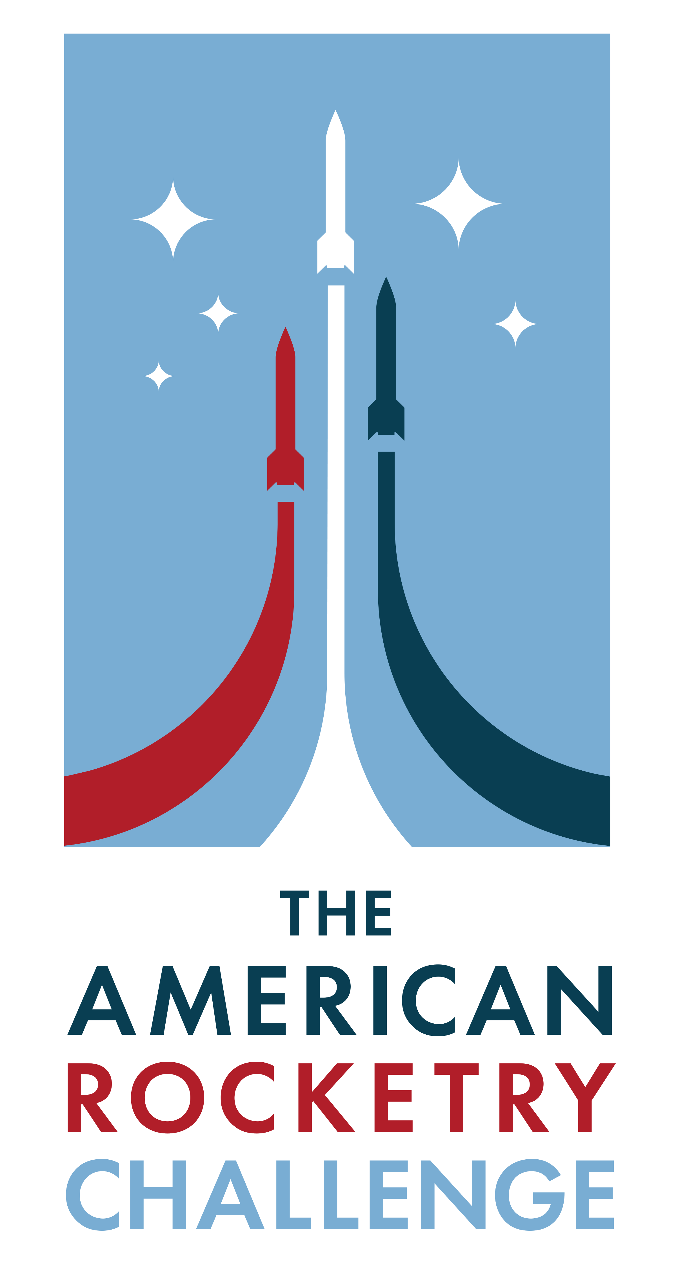
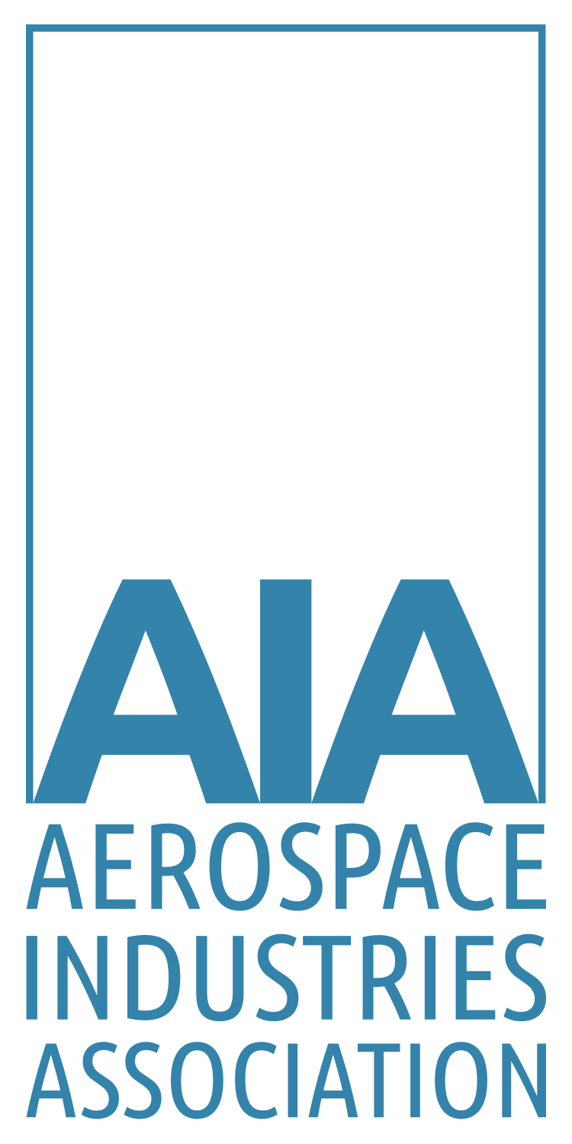
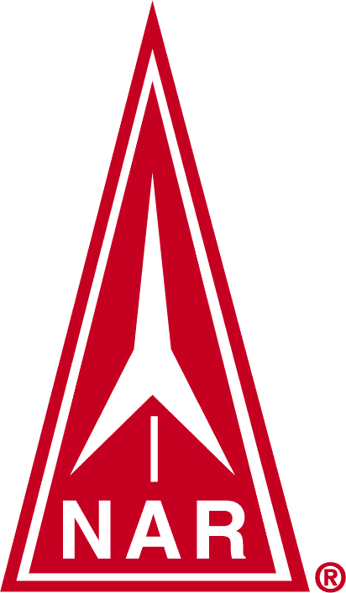

www.aia-nas.org

TABLE OF CONTENTS

1. scope 3
2. CONTEST RULES 3
2.1 SAFETY 3
2.2 TEAMS 3
2.3 ROCKET REQUIREMENTS 3
2.4 PAYLOAD 4
2.5 DURATION SCORING 4
2.6 ALTITUDE SCORING 4
2.7 FLIGHTS 4
2.8 SAFE RECOVERY 5
2.9 RETURNS 5
2.10 LAUNCH SYSTEMS 5
2.11 FLIGHT CONTROL 5
2.12 PLACES 5
3. AIA’s National Aerospace Standards 6

scope
This document provides the rules for the 2021 American Rocketry Challenge.

CONTEST RULES

SAFETY
All rockets must be built and flown in accordance with the Model Rocket Safety Code of the National Association of Rocketry (NAR), any applicable local fire regulations, and Federal Aviation Regulations. Rockets flown at the Finals must have previously flown safely and successfully. Rockets will be inspected before launch and observed during flight by a NAR official, whose judgment on their compliance with the Safety Code and with these rules will be final. Teams are encouraged to consult with designated NAR officials who are running this event well before the fly-off to resolve any questions about design, the Safety Code, or these rules.

TEAMS
The application for a team must come from a single school or a single U.S. incorporated non-profit youth or educational organization (excluding the National Association of Rocketry, Tripoli Rocketry Association, or any of their local chapters or any other incorporated rocket organization). There is no limit to the number of teams that may be entered from any single school or organization, but no more than two teams containing students who attend the same school or who are members of the same organization, regardless of whether the teams are sponsored by that school or organization, can be invited to attend the Finals. Team members must be students who are currently enrolled in grades 6 through 12 in a U.S. school or homeschool. Teams may have members from other schools or other organizations and may obtain financing from any source, not limited to their sponsoring organization. Teams must be supervised by an adult approved by the principal of the sponsoring school, or by an officially-appointed adult leader of their sponsoring organization. Minimum team size is three students and maximum is ten students. Each student member must make a significant contribution to the designing, building, and/or launching of the team's entry. No part of any of these activities for a rocket used in a qualification flight or at the Finals may be done by any adult, by a company (except by the sale of standard off-the-shelf components available to the general public, but not kits or designs for the event), or by any person not a student on that team. No student may be on more than one team. The supervising teacher/adult may supervise more than one team. The Challenge is open to the first 1000 teams that submit a completed application, including payment, postmarked between September 1 and December 1, 2020. Teams that were enrolled in TARC 2020 are automatically enrolled in TARC 2021 without additional forms or payment.

ROCKET REQUIREMENTS
Rockets must not exceed 650 grams gross weight at liftoff. The overall length of the rocket must be no less than 650 millimeters (25.6 inches) as measured from the lowest to the highest points of the airframe structure (including fins) in launch configuration. All portions of the rocket must remain connected or tethered together from takeoff until landing and the rocket must recover by parachute. Rockets must have the team’s official TARC entry number written on them. Rockets flown at the Finals will be required to have a paint or other decorative coating applied to any wood, paper, or fiber exterior surface of the rocket and will be assessed a 5-point flight score penalty on their first flight at the Finals if they do not. Rockets may not be commercially-made kits designed to carry egg payloads with the only modification being the addition of an altimeter compartment. They must have only one stage. They must be powered only by commercially-made model rocket motors of “F” or lower power class that are listed on the TARC Certified Motor List posted on the TARC website and provided in the TARC Handbook. Any number of motors may be used, but the motors used must not contain a combined total of more than 80 Newton-seconds of total impulse based on the total impulse ratings in the TARC list. Motors must be retained in the rocket during flight and at ejection by a positive mechanical means (clip, hook, screw-on cap, etc.) and not retained simply by friction fit in the motor mounting tube. Rockets must not contain any pyrotechnic charges except those provided as part of the basic commercially-made rocket motor used for the flight, and these must be used only in the manner prescribed in the instructions for that motor.

PAYLOAD
Rockets must contain and completely enclose one raw hen's egg of 55 to 61 grams weight and a diameter of 45 millimeters or less; and must return it from the flight without any cracks or other external damage. The egg will be issued to the teams by event officials during the Finals, but teams must provide their own egg for their qualifying flights. The egg and altimeter must be removed from the rocket at the end of a qualification or Finals flight in the presence of a designated NAR official and presented to that official, who will inspect the egg for damage after its removal and will read the altimeter score. All coatings, padding, or other materials used to protect the egg must be removed by the team prior to this inspection. Any external damage to the egg noted after their flight and removal from the rocket by the team is disqualifying.

DURATION SCORING
The duration score for each flight shall be based on total flight duration of the rocket, measured from first motion at liftoff from the launch pad until the moment that the first part of the rocket touches the ground (or a tree) or until it can no longer be seen due to distance or to an obstacle. Times must be measured independently by two people not on the team, one of whom is the official NAR-member adult observer, using separate electronic stopwatches that are accurate to 0.01 seconds. The official duration will be the average of the two times, rounded to the nearest 0.01 second, with .005 seconds being rounded up to the next highest 0.01 seconds. If one stopwatch malfunctions, the remaining single time will be used. The flight duration goal is a range of 40 to 43 seconds. Flights with duration in the range of 40 to 43 seconds get a perfect duration score of zero. Duration scores for flights with duration below 40 seconds will be computed by taking the absolute difference between 40 seconds and the measured average flight duration to the nearest 1/100 second and multiplying this by 4. Duration scores for flights with durations above 43 seconds will be computed by taking the absolute difference between 43 seconds and the measured average flight duration to the nearest 1/100 second and multiplying this by 4. These duration scores are always a positive number or zero. The target duration for flights at the Finals will be 1 second less or 1 second more, with the order for these between first and second flights determined by a coin toss at the student team pre-flight briefing at the Finals. Scoring for flights with durations above or below this revised range will be aligned to match the procedures for the 40-43 second range.

ALTITUDE SCORING
Rockets must contain one and only one electronic altimeter of the specific commercial types approved for use in the American Rocketry Challenge. These types are the Perfectflite APRA, Pnut, or Firefly. The altimeter must be inspected by an NAR official both before and after the flight, and may not be modified in any manner. The altimeter must be confirmed by this official before flight to not have been triggered and to be ready for flight. The peak altitude of the rocket as recorded by this altimeter and sounded or flashed out on its audible or visible light transmission post-flight will be the sole basis for judging the altitude score and this altimeter may be used for no other purpose. Other altimeters of other types may be used for flight control or other purposes. The altitude performance goal for qualification flights is 800 feet (244 meters). The altitude score will be the absolute difference in feet between the altitude performance goal in feet and the altimeter-reported actual flight altitude in feet (always a positive number or zero). The altitude performance goal for flights at the Finals will be 775 feet or 825 feet, with the order for these between first and second flights determined by a coin toss at the student team pre-flight briefing at the Finals. The altitude and duration goals will be set by a single coin toss, with the 775 foot altitude goal going with a 39-42 second duration goal and the 825 foot altitude goal going with a 41-44 second duration goal.

FLIGHTS
Team members cannot be changed after the first qualification flight that is made after September 1, 2020, with one exception as noted below for the Finals. Teams that were enrolled in TARC 2020 and carried over into TARC 2021 may change their membership up until the point that they fly a qualification flight made after September 1, 2020. Only team members on record at the Aerospace Industries Association (AIA) with valid parent consent forms are eligible to receive prizes. To be eligible for the national final fly-off event, a team is required to fly and submit the results from at least two qualifying flights observed in person by an adult (senior) member of the NAR (unrelated to any team members or to the team’s adult supervisor and not a paid employee of their school or member of their youth group) between September 1, 2020 and Monday, April 5, 2021. Each team may conduct a maximum of three qualification flights, and will be ranked based on the sum of the best two qualified flights. More than two qualification flights are not required if the team is satisfied with the results of their first two flights. Qualification flights made before April, 2020 by teams that were enrolled in TARC 2020 will be carried over into TARC 2021 unless the team requests to have them all removed. A qualification flight attempt must be declared to the NAR observer before the rocket's motor(s) are ignited. Once an attempt is declared, the results of that flight must be recorded and submitted to the AIA, even if the flight is unsuccessful. A rocket that departs the launch rail or rod under rocket power is considered to have made a flight, even if all motors do not ignite. If a rocket experiences a rare "catastrophic" malfunction of a rocket motor (as determined by the NAR official observer), a replacement flight may be made, with a replacement vehicle if necessary. Flights which are otherwise fully safe and qualified but which result in no altimeter reading despite correct usage of the altimeter by the team, or that result in a reading of less than 50 feet despite a nominal flight will be counted as “no flight” and may be reflown without penalty. The results from qualification flight attempts must be faxed or scanned and e-mailed to and received at the offices of the AIA by 11:59 PM Eastern time on Monday, April 5, 2021. Based on these qualification scores 100 teams (with a limit of no more than the best two made up of students from any single school or organization) will be selected on the basis of lowest combined scores for their best two flights. If a school has more than two teams whose flight score is better than the cutoff score for Finals selection, they may adjust the membership of the two best teams invited to attend the Finals to include students from other teams with scores that met the Finals cutoff, up to a limit of ten students on any single team. Teams will be notified no later than 5 PM on Friday, April 9, 2021, and will be invited to participate in the final fly-off to be held on May 15, 2021 (alternate date in case of inclement weather will be May 16, 2021).

SAFE RECOVERY
Every portion of the rocket must return to earth safely and at a velocity that presents no hazard. An entry which has any heavy structural part or an expended motor casing separate from the rest and fall to earth without any form of recovery device will be disqualified. The rocket must be allowed to land at the end of flight without human intervention (catching) and the flight will be disqualified if there is such intervention.

RETURNS
Return of the entire rocket is required by the deadline time on that same day that was established at the beginning of the day's flying. If the rocket cannot be returned after an otherwise safe and stable flight because it cannot be located or because it landed in a spot from which recovery would be hazardous (as determined by an NAR official), a replacement vehicle may be substituted for a replacement flight. Once the NAR official has declared that a rocket has landed in a place from which recovery would be hazardous, the results from that rocket’s flight may not subsequently be used even if it is recovered.

LAUNCH SYSTEMS
Teams may use the electrical launch system and the launch pads (with six-foot long, 1-inch rails) provided by the event officials or may provide their own rail or tower system as long as it provides at least six feet of rigid guidance; launch rods will not be permitted to be used at the Finals. Launch systems used locally for qualification flights prior to the Finals must provide the rocket with at least six feet of rigid guidance, with a rail or with use of a rod diameter of at least 1/4 inch, if a rod is used. All launches will be controlled by the event Range Safety Officer and must occur from the ground.

FLIGHT CONTROL
Rockets may not use an externally-generated signal such as radio or computer control (except GPS navigation satellite signals) for any purpose after liftoff. They may use autonomous onboard control systems to control any aspect of flight as long as these do not involve the use of pyrotechnic charges.

PLACES
Places in the final fly-off of the competition will be determined on the basis of the sum of the altitude and duration scores. At the fly-offs, at least 24 teams will be invited to make a second flight based on the results of their first flights. In these second flights, rockets which have issues which would otherwise rate a replacement flight under TARC rules #7 or #9 will not receive a replacement flight. Prizes awarded to the top places will be awarded only to those teams that make a second flight. The top final places will be ranked on the basis of the scores from the two qualified flights made at the fly-offs. Remaining places will be awarded based on the scores from the first flight. Ties will result in pooling and even splitting of the prizes for the affected place(s) -- for example, a two-way tie for 4th place would result in a merger and even division of the prizes for 4th and 5th places. If there is a tie for one of the top three places, the teams involved in the tie will be required to make a third flight to determine final places. Aerospace Industries Association reserves the right to make all last and final contest determinations.

AIA’s National Aerospace Standards
This document is an example of what a voluntary consensus standard might look like within the Aerospace industry. The Aerospace Industries Association organizes and facilitates groups of subject matter experts to write, approve, and publish National Aerospace Standards that contain requirements and best practices, which are adopted by companies and governments around the world. Standards help to reduce costs and improve safety in design, manufacturing, and operations. AIA’s National Aerospace Standards program is a vast collection of technical information and requirements that have been developed and maintained by the industry since 1941. For more information on AIA’s National Aerospace Standards go to: www.aia-nas.org.

