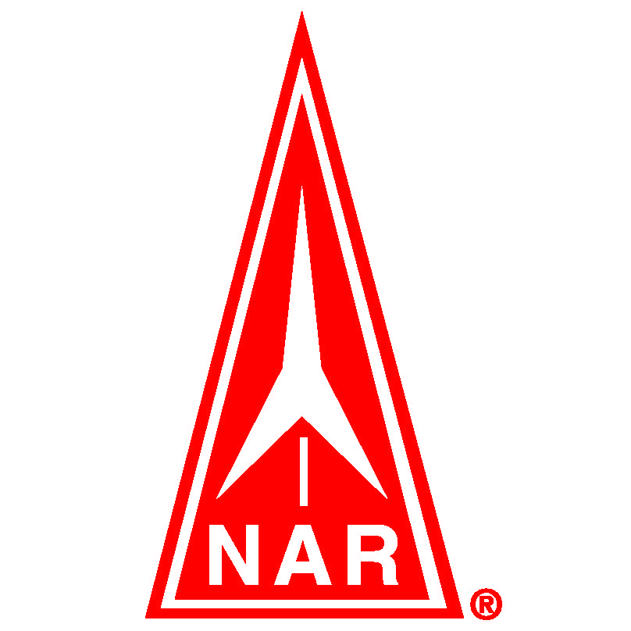**National Association of Rocketry**

**Extracurricular Activity Grant Application**

**Due date:** June 1

**Organization**

OrganizationName:\_\_\_\_\_\_\_\_\_\_\_\_\_\_\_\_\_\_\_\_\_\_\_\_\_\_\_\_\_\_\_\_\_\_\_\_\_\_\_\_\_\_\_\_\_\_\_\_\_\_\_\_\_\_\_\_\_\_\_\_\_

Address:\_\_\_\_\_\_\_\_\_\_\_\_\_\_\_\_\_\_\_\_\_\_\_\_\_\_\_\_\_\_\_\_\_\_\_\_\_\_\_\_\_\_\_\_\_\_\_\_\_\_\_\_\_\_\_\_\_\_\_\_\_\_\_\_\_\_\_\_\_

❐ public school  private school  other(explain)\_\_\_\_\_\_\_\_\_\_\_\_\_\_\_\_\_\_\_\_\_\_\_\_\_\_\_\_

**Applicant**

Name: \_\_\_\_\_\_\_\_\_\_\_\_\_\_\_\_\_\_\_\_\_\_\_\_\_\_\_\_\_\_\_\_\_\_\_\_\_\_\_\_\_\_\_\_\_\_\_\_\_\_\_\_\_\_\_\_\_\_\_\_\_\_\_\_\_\_\_\_\_\_

Mailing Address:\_\_\_\_\_\_\_\_\_\_\_\_\_\_\_\_\_\_\_\_\_\_\_\_\_\_\_\_\_\_\_\_\_\_\_\_\_\_\_\_\_\_\_\_\_\_\_\_\_\_\_\_\_\_\_\_\_\_\_\_\_\_\_

Email address \_\_\_\_\_\_\_\_\_\_\_\_\_\_\_\_\_\_\_\_\_\_\_\_\_\_\_\_\_\_\_\_\_\_\_\_\_\_\_\_\_\_\_\_\_\_\_\_\_\_\_\_\_\_\_\_\_\_\_\_\_\_\_\_

Position at organization:  teacher  other (explain) \_\_\_\_\_\_\_\_\_\_\_\_\_\_\_\_\_\_\_\_\_\_\_\_\_\_\_\_\_\_\_

Are you a member of the NAR?  yes, NAR # \_\_\_\_\_\_\_\_\_\_\_\_\_\_\_\_\_\_\_\_  no

**Activity Participants**

Grade level of participants (check all that apply):

❐ K  1  2  3  4  5  6  7  8  9  10  11  12

Number of participants: \_\_\_\_\_\_\_\_\_\_\_

*\_\_\_\_\_\_\_\_\_\_\_\_\_\_\_\_\_\_\_\_\_\_\_\_\_\_\_\_*

Brief description of activity (200 words or less recommended):

**Attach a lesson plan (preferred) or an activity description.** The lesson plan can be original or adapted from a lesson plan by a third-party (for example NASA, NSTA, science museums, space grant consortium, etc.). Please properly attribute your sources.

**Continuation Plans**

Do you plan to continue this activity in future years?    yes  no

If you answered yes, please explain your plans:

Has this activity been supported by an NAR Grant before?  yes  no

Have you done this specific activity before?  yes  no If yes, how will this activity be improved or refined this time?

**Facilities**

Briefly explain the facilities to be used for the activity, including the launch field, if applicable.

Will the local NAR club be involved?  yes  no

**Publicity**

Will parents, other spectators, or local press be present?

**Expenses**

Explain how you will use the award money – We don’t need a detailed budget.

**National Association of Rocketry**

**Extracurricular Activity Grant Application**

**Checklist**

Applicant: \_\_\_\_\_\_\_\_\_\_\_\_\_\_\_\_\_\_\_\_\_\_\_\_\_\_\_\_\_\_\_\_\_\_\_\_\_\_\_\_\_\_\_\_\_\_\_\_\_\_\_\_\_\_\_\_\_\_\_\_\_\_

Organization:\_\_\_\_\_\_\_\_\_\_\_\_\_\_\_\_\_\_\_\_\_\_\_\_\_\_\_\_\_\_\_\_\_\_\_\_\_\_\_\_\_\_\_\_\_\_\_\_\_\_\_\_\_\_\_\_\_\_\_\_\_\_

❐ I have filled out all fields in the application.

❐ I have included a brief (about 200 words or less) activity description.

❐ I have attached a lesson plan or activity description.

 My name is written on the upper right-hand side of all parts of the application, including the attachments.

❐ I have read the Extracurricular Activity Grant eligibility requirements and I believe that this activity satisfies those requirements.

Signature\_\_\_\_\_\_\_\_\_\_\_\_\_\_\_\_\_\_\_\_\_\_\_\_\_\_\_\_\_\_\_\_\_\_\_\_\_\_\_ Date \_\_\_\_\_\_\_\_\_\_\_\_\_\_\_\_\_\_\_\_\_\_

Order of submission: *(please do not staple)*

Checklist

Application (with brief description of activity)

Lesson plan or activity description attachment

To submit, mail to: **National Association of Rocketry**

**Extracurricular Activity Grant**

**P.O. Box 407**

**Marion, IA 52302**

or E-mail scanned signed version to: **[jguzik@mindspring.com](mailto:jguzik@mindspring.com)**

If you have additional questions or need more information, please contact:

Joyce Ann Guzik, NAR Trustee

Email: [jguzik@mindspring.com](mailto:jguzik@mindspring.com" \t "_blank)